Name: Muhammad Haider Qadri

Roll Number: P260018

Section: AI-1A

Semester: 1st

Course Details: Learning fundamentals of programming and logic development using C
Date: 8/28/2026

PF LAB TASKS :

Task 1:

Code:
# PF-Lab02
## Name: Muhammad Haider Qadri
## Roll Number: P26-0018
## Section: BS AI-1A (Aaise Rabbani)

Output:
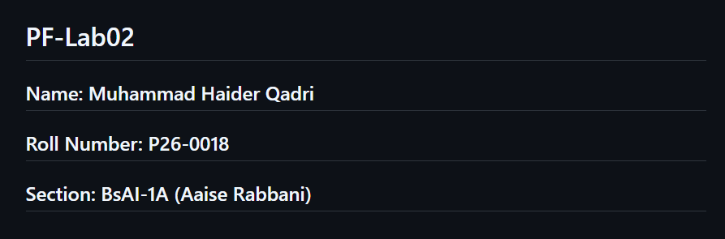

Task 2:

Code:
#include <stdio.h>
int main() {
int Batch=2026;
char Section='A';
float Entry_Test_Score=68.9;
double Semester_Tuition_Fee=212500.5;
printf("=======================================================\n\t\t\tFAST NUCES STUDENT PROFILE CARD\n=======================================================\n");
printf("Batch year: \t%d\n",Batch);
printf("Section: \t%c\n",Section);
printf("Test Score: \t%f\n",Entry_Test_Score);
printf("Semester Fee:\tPKR %f\n",Semester_Tuition_Fee);
printf("Motto: \t\"Small daily steps lead to big Success\"\n");
printf("=======================================================");
return 0;}

Output:
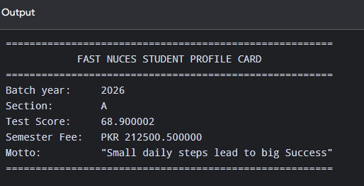

Task 3:

Code:
#include <stdio.h>
int main() {
printf("=================== C ESCAPE SEQUENCE REFERENCE ================\n");
printf("To print a double quote, write: \t\\\" \n");
printf("To print a literal backslash, write: \t\\\\ \n");
printf("To print a newline break, write: \t\\n \n");
printf("To print a horizontal tab stop, write:\t\\t \n");
printf("To print a percent sign, write: \t%%% \n");
printf("=================================================================");
return 0;
}

Output:
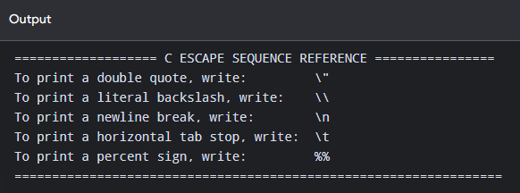

Task 4:

Code:
#include <stdio.h>
int main() {
int a=20;
char b='M';
float c=1.134;
double d=11.45671;
printf("Type Name\tVariable Value\t Size in Memory\n");
printf("--------------------------------------------\n");
printf("Char \t \t '%c' \t \t\t\t%dbyte(s)\n",b,sizeof(b));
printf("Int \t \t %d \t \t\t\t%dbyte(s)\n",a,sizeof(a));
printf("Float \t \t %f \t\t\t%dbyte(s)\n",c,sizeof(c));
printf("Double \t \t %f \t\t%dbyte(s)\n",d,sizeof(d));
printf("--------------------------------------------\n");

return 0;}

Output:
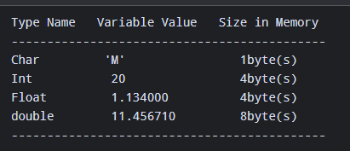

Task 5:

Code:
#include <stdio.h>
int main() {
float Celsius=37.5;
float Fahrenheit=(Celsius*9.0/5.0)+32.0;
float Kelvin=Celsius+273.15;
printf("========== TEMPERATURE CONVERSION ==========\n");
printf("Temperature in celsius: \t\t%.2f °C\n",Celsius);
printf("Temperature in fahrenheit:\t\t%.2f °F\n",Fahrenheit);
printf("Temperature in kelvin: \t\t%.2f K\n",Kelvin);
printf("============================================");
return 0;
}

Output:
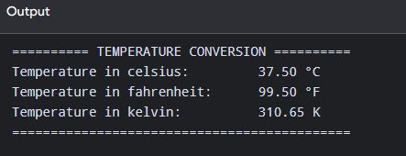

Task 6:

Code:
#include <stdio.h>
int main() {
float radius=7.5;
const float pi =3.14159;
printf("========== CIRCLE GEOMETRY REPORT ==========\n");
printf("Given Radius: \t%.3f cm\n",radius);
printf("Calculated Diameter: \t%.3f cm\n",radius*2);
printf("Calculated Circumference: \t%.3f cm\n",2*pi*radius);
printf("Calculated Area: \t%.3f sq.cm\n",pi*radius*radius);
printf("============================================\n");

return 0;
}

Output:
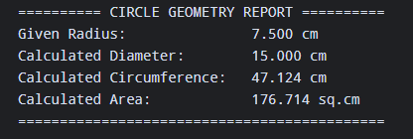

Task 7:

Code:
#include <stdio.h>
int main() {
float vi=12.5;
float a=3.2;
float t=6.0;
printf("========== KINEMATICS MOTION REPORT ==========\n");
printf("Initial velocity (vi):\t\t%.2f m/s\n",vi);
printf("Acceleration (a): \t\t%.2f m/s^2\n",a);
printf("Time Elapsed (t): \t\t%.2f s\n",t);
printf("----------------------------------------------\n");
printf("Calculated Final Velocity (vf): %.2f m/s \n",vi+(a*t));
printf("Calculated Distance (S): %.2f m \n",(vi*t)+(0.5*a*t*t));
printf("==============================================");
return 0;
}

Output:
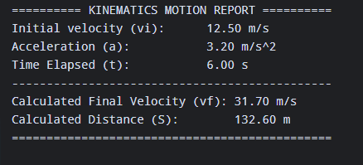

Task 8:

Code:
#include <stdio.h>
int main() {
double principal_amount=250000; //in pkr
float rate=8.5; //8.5%
int time=3; //in years
printf("========== BANK LOAN INTEREST SUMMARY ==========\n");
printf("Principal Amount: \t\tPKR %.2f \n",principal_amount);
printf("Annual Interest rate:\t\t%.2f%%\n",rate);
printf("Loan duration: \t\t%d Years\n",time);
printf("------------------------------------------------\n");
double I=(principal_amount*rate*time)/100.00;
printf("Total Accrued interest:\tPKR %.2f\n",I);
printf("Total Payable Amount: \tPKR %.2f\n",principal_amount+I);
printf("Monthly Installment: \tPKR %.2f\n",(principal_amount+I)/(time*12.0));
printf("================================================");
return 0;
}

Output:
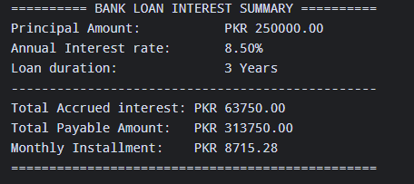

Task 9:

Code:
#include <stdio.h>
int main() {
double basic_salary=85000.00;
printf("========== MONTHLY SALARY SLIP ==========\n");
printf("Basic Salary: \tPKR %.2f\n",basic_salary);
printf("House Rent Allowance: \tPKR %.2f\n",0.20*basic_salary);
printf("Medical Allowane: \tPKR %.2f\n",0.10*basic_salary);
printf("------------------------------------------------\n");
double gross_salary=basic_salary+(0.20*basic_salary)+(0.10*basic_salary);
printf("Gross salary: \t\t\t\tPKR %.2f\n",gross_salary);
printf("Tax Deduction:\t\t\t\tPKR %.2f\n",0.05*gross_salary);
printf("------------------------------------------------\n");
printf("Net Payable salary\t\t\tPKR %.2f\n",gross_salary-(0.05*gross_salary));
printf("================================================");
return 0;
}

Output:
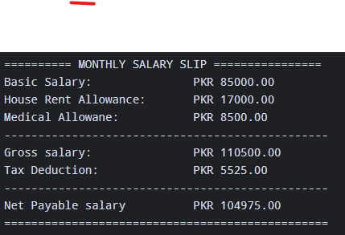

Task 10:

Code:
#include <stdio.h>
int main() {
float marks_PF=88.0;
float credithours_PF=3.0;
float marks_calc_AG=76.5;
float credithours_calc_AG=3.0;
float marks_AP=82.0;
float total_weighted_score=(88.0*3.0)+(76.5*3.0)+(82.0*2.0);
float total_credit_hours=3.0+3.0+2.0;
float avg_percentage=total_weighted_score/total_credit_hours;
float credithours_AP=2;
printf("=========== SEMESTER ACADEMIC REPORT ===========\n");
printf("Course\t\tCredit Hours\t\tObtained Mars\n");
printf("------------------------------------------------\n");
printf("PF:\t\t\t%.2f\t\t\t\t%.2f\n",credithours_PF,marks_PF);
printf("Calculus:\t%.2f\t\t\t\t%.2f\n",credithours_calc_AG,marks_calc_AG);
printf("AP:\t\t\t%.2f\t\t\t\t%.2f\n",credithours_AP,marks_AP);
printf("------------------------------------------------\n");
printf("Total Credits:\t%.2f\tWeighted Average:\t%.2f%%\n",total_credit_hours,avg_percentage);
printf("================================================");
return 0;
}

Output:
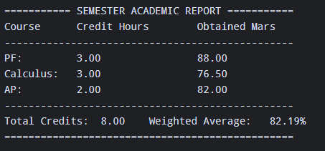

Task 11:

Code:
#include <stdio.h>
int main() {
float tea_qty=3;
float tea_price=60;
float samosa_qty=4;
float samosa_price=40.50;
float chickenroll_qty=2;
float chickenroll_price=120;
printf("================= FAST CAFETERIA RECEIPT =================\n");
printf("Item\t\t\tQty\t\t\tUnit Price\t\t\tSubtotal\n");
printf("----------------------------------------------------------\n");
printf("Tea\t\t\t\t%.2f\t\t%.2f\t\t\t\t%.2f\n",tea_qty,tea_price,tea_qty*tea_price);
printf("Samosa\t\t\t%.2f\t\t%.2f\t\t\t\t%.2f\n",samosa_qty,samosa_price,samosa_qty*samosa_price);
printf("ChickenRoll\t\t%.2f\t\t%.2f\t\t\t\t%.2f\n",chickenroll_qty,chickenroll_price,chickenroll_qty*chickenroll_price);
float subtotal=(chickenroll_qty*chickenroll_price)+(samosa_qty*samosa_price)+(tea_qty*tea_price);
printf("----------------------------------------------------------\n");
printf("Subtotal:\t\t\t\t\t\t\t\t\t\tPKR %.2f\n",subtotal);
printf("GST:\t\t\t\t\t\t\t\t\t\t\tPKR %.2f\n",0.16*subtotal);
printf("==========================================================\n");
printf("Grand Total:\t\t\t\t\t\t\t\t\tPKR %.2f\n",(subtotal*0.16)+subtotal);
printf("================= THANK YOU FOR YOUR VISIT ===============\n");
return 0;
}

Output:
